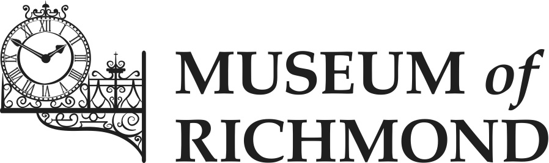 **My Lockdown Memories**   
by

**Funniest lockdown moment:**

**What I miss the most in lockdown?**

**Best Lockdown smell:**

**A photograph or picture I made that will always remind me of lockdown:**

**Best Lockdown taste:**

**An object that will always remind me of lockdown:**

**Something new I learnt during   
lockdown:**

**Something that made me happy during lockdown:**