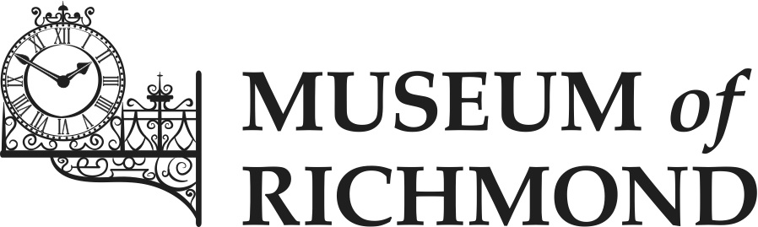

Learning Plan

Date created: May 2016
Date for review: June 2019
Author: Morag Calderbank (Learning and Audience Development Officer)

1. Introduction
1.1 The Museum of Richmond offers a variety of formal and informal learning programs and resources for a variety of audiences. Through learning programs of the highest quality, the Museum aims to engage and inspire visitors to look more closely at and understand better the history of Richmond upon Thames. The audiences we serve include students of all ages, adult learners, SEN groups, families and home school groups.
1.2 The Learning Officer uses the Museum’s display collections, temporary and permanent exhibitions, a varied handling collection, archive material and the local area as teaching resources.

2. Current learning activities:
The Museum runs approximately 50 in-house school sessions a year, the majority of which are KS1 and KS2.
2.1 The Museum offers the following learning sessions for KS1
- Toys in the Past
- Homes Long Ago
- What are we Remembering on Remembrance Day?

2.2 The Museum offers the following learning sessions for KS2
- Tudor Life in Richmond
- Romans in Britain: A Case Study of Roman Life
- Being a Child in Second World War Richmond
- WWI in the Borough of Richmond upon Thames
- How Life has Changed in Our Locality
- Children Living in Victorian Richmond
- Chronological Richmond

2.3 Additional learning activities

- The Museum can adapt KS2 sessions to meet the requirements of Key Stage 3&4 students.
- The Museum takes part in outreach sessions for schools and groups who are unable to attend the Museum in person. Outreach groups include children’s hospitals, old people’s homes and other vulnerable groups.
- The Museum loans out discovery boxes to schools and learning groups. Topics include Holidays in the Past, Tudors, Romans, Victorian Children, Victorian and Edwardian Household Objects.
- Regular talks, walks and poetry mornings are held at the Museum for adult learners. Adult learners and SEN groups are encouraged to contact the Museum to arrange tours of the Museum and its collections.
- Week long historically themed family workshops take place every school holiday for families and children aged 5-11 years old.
- The Museum provides learning activities for local events such as Richmond May Fair and the Archaeology Festival.
- The Museum runs a Young Curators Group for local sixth form students.
- The Museum runs a work experience programme for at least four work experience students per year from local schools and colleges. Work experience placements are usually for one or two weeks. In addition the Museum offers a two day work experience placement for two teacher training students per year.
- The Museum works in partnership with Richmond Adult and Community College fashion students to run at least one event together a year.
- The Museum organises a learning internship for 3 young adults per year for the duration of 3 months. A learning intern will work one day p/week and the opportunity provides them with first hand experience of working in a museum.

3. Action Plan
This table is for extra activities the Museum will be working on over the next two years. The table includes a continuation of all the current and additional learning activities listed above.
Year One 2016-17 | Year Two 2017-18
To develop new learning sessions for Key Stage 3 & 4: this year a new session for World War One and World War Two is being developed in collaboration with Local Studies.  Target other groups to take part in learning sessions such as TSOL groups, Home schooling groups, Girl Guides  Take part in the Challenge Network scheme for 16-18 year olds, offering them an interactive museum experience.  Extend the number of Secondary School visits to 8 a year.  Investigate participation in the young people’s museum takeover scheme ‘Kids in Museums’  Contact careers officers in local schools and colleges with the aim of Museum staff contributing to careers fairs.  Increase Museums at Night participation to twice a year.  Take part in outreach sessions at school assemblies and staff meetings | To develop new learning sessions for Key Stage 3 & 4 related to temporary exhibitions e.g Poverty in Richmond  Extend the number of Secondary School visits to 12 a year.  Create a Richmond History Challenge based on temporary exhibitions for Secondary students e.g Richmond Poverty Challenge  Creating a competition around a topical history subject e.g Black History month  Investigate participation in Arts Award  Investigate developing a Richmond walk for Adult Learners

