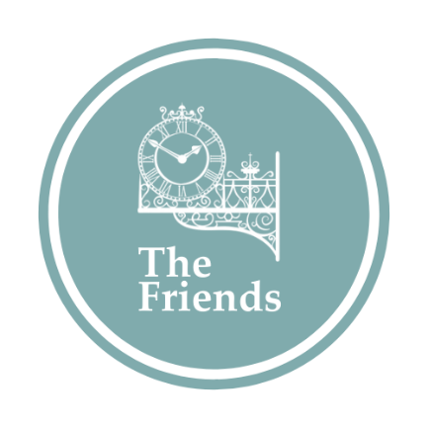 | Membership Form
Thank you for joining the Friends! We very much appreciate your support of the Museum of Richmond. Once we have received this form and payment, we will send you confirmation of your membership, and details of how you can start using your benefits!
Name:
Address, including postcode:
Email, so you can receive your newsletter, invites to events and updates from the Museum:
Joint Friend Name:
(if applicable)
Joint Friend Email:
(if applicable)

Please select ONE from the following:
Lifetime Membership: £150 for an individual, £250 for joint membership
I have completed a card payment of £150/£250 with the Museum Team
I have set up a one off payment for £150 /£250, using my online banking facility and the details below.
Please find enclosed a cheque of £150 / £250 made payable to The Museum of Richmond.
Annual Membership: £15 for an individual, £25 for joint membership
I have completed a card payment of £15/£25 with the Museum Team
I would like to set up a new Direct Debit and have provided an email address for this purpose on the previous page.
I have set up a one off payment of £15/£25, using my Online Banking facility.
Please find enclosed a cheque for £15/£25, made payable to The Museum of Richmond.
The Museum of Richmond’s Bank details are:
CAF Bank Ltd, 25 Kings Hill Avenue, Kings Hill, West Malling, Kent ME19 4JQ
Sort code – 40-52-40
Account number – 00001889
Please use the reference: FS1244

