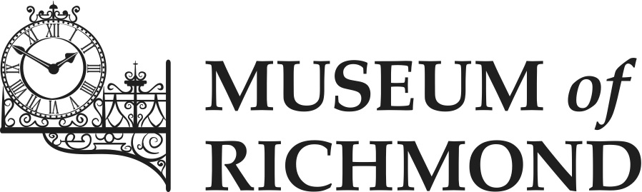

Access Policy Statement

Date created: May 2016
Date for review: June 2019
Author: Morag Calderbank (Learning and Audience Development Officer)

MUSEUM of RICHMOND

- Introduction

1.1 The Museum of Richmond seeks to interpret the material evidence of Richmond’s past for the public’s benefit, education and enjoyment. We undertake to make the Museum’s collections available to the fullest extent possible, to the widest possible spectrum of people from all sections of the community. We do, however, acknowledge that access to the collections will be balanced against the care and management of the collections, regarding which reference should be made to the Museum’s Care and Conservation Policy.

1.2 Access to the Museum and its collections is also affected by the building in which the Museum is located as a lessee of the London Borough of Richmond upon Thames. Where possible, we will work with the Council to maintain and improve access.

1.3 Accessibility to the Museum is enhanced when physical, sensory, intellectual, financial, social, and cultural barriers to learning from, and enjoyment of, the Museum are removed, reduced or overcome. Our policy is to identify and reduce or eliminate barriers, as our resources permit. To do this, we will seek to consult with and get feedback from users and, where possible, non-users and carry out access assessments periodically.

- Assessing access

2.1 Physical access – can people with physical disabilities (and people caring for young children) reach and appreciate every part of the Museum? Current provision includes lift access from street level, level access within the Museum, seating at various points in the gallery, with access information on the Museum’s website.

2.2 Sensory access – can our exhibitions and events be used by people with hearing or sight impairments? Current provision includes objects in the gallery that can be touched, large, clear font used on exhibition texts as standard, magnifying glass available at the information desk for public use.

2.3 Intellectual access – do our exhibitions exclude people with limited background knowledge? Can people with learning disabilities access our services? Further consultation with users required. Current provision includes education sessions designed for students with learning difficulties.

2.4 Financial access – are people on low incomes deterred from using our services? There is free admission to the Museum. As a charity, we need to raise income but, while fees are charged for some of our events, for most we suggest a donation. Low cost stock is available in our shop.

2.5 Social access – Are the Museum environment and staff welcoming to visitors from all sections of the community? Current provision includes a customer care element in Desk Volunteer training. Consider the special events programme with a view to ensuring that it includes activities aimed at building confidence amongst new audiences.

2.6 Cultural access – Do our collections, displays and events reflect the interests and life experiences of our target audience? Current provision includes organising temporary displays on a range of subjects and a wide range of accompanying events.

- Further to the above areas, we undertake to:

3.1 Include the Museum’s website and publicity material when looking at access. Consider legibility, ease of use, and ensure that access information is accurate and up to date.

3.2 Provide access to objects in the collection that are not on display. This is currently done by making objects available to researchers by appointment, by store tours, by making handling collections available in the Museum and on outreach.

3.3 Provide disability awareness training for staff as required and ensure that the Museum complies with the relevant legislation, such as the Equality Act.

3.4 Review this policy at least every three years.

- Current access facilities and resources

4.1 The Museum is on the second floor of the Old Town Hall and is accessible for visitors with access requirements.

4.2 Wheelchair users are asked to use the lift at the back of the Old Town Hall on Whittaker Avenue. To use the lift, visitors contact a member of Old Town Hall staff by using the button and speaker beside the lift. A staff member mans the lift to provide access to the ground floor. From the ground floor the lift to the right of the marble stair case is used to take visitors up to the second floor for the Museum.

4.3 Blind or partially sighted visitors; magnifying glasses are available and may be obtained from a volunteer at the Front Desk. Assistance dogs are welcome. The Museum is able to arrange handling sessions for blind and partially-sighted visitors by appointment.

4.4 Deaf and hard of hearing visitors; we are able to arrange by appointment a lip reading tour for deaf and hard of hearing visitors.

4.5 Mobility access; chairs are located in each bay of the Museum and additional chairs can be provided at the front desk.

4.6 Additional learning needs; by appointment we can arrange handling sessions, involving original and replica objects for visitors with additional learning needs.

