**MR_clock_logo_black_background**

Old Town Hall • Whittaker Avenue ⦁ Richmond • Surrey tw9 1tp

Telephone: 020 8332 1141 ⦁ Email: museumofrichmond@btconnect.com

royal patron Her Royal Highness Princess Alexandra, the Hon. Lady Ogilvy, kg gcvo

patrons Sir David Attenborough, Greville Dare, Julian Lord Fellowes, Bamber Gascoigne,

Lady Annabel Goldsmith, Andrew Marr, Alan Lord Watson

vice chair Pat Astley-Cooper MBE

curator Natascha Wintersinger

21st April 2015

The Museum of Richmond is honoured to announce that Julian, Lord Fellowes of West Stafford, has very kindly agreed to become a Patron of the Museum.

He said, in accepting the invitation, “I admire and support the museum and I would like to be a patron very much.”

Lord Fellowes has already been a great friend of the Museum, having given talks in 2009 and 2013 in aid of the Museum’s renewal appeal. He also lent the Museum the portrait of his paternal great, great, great, great aunt, Georgina Gill, daughter of Admiral Sir Thomas Fellowes, for its exhibition “Living and Dying in Nineteenth Century Richmond”. The photograph below shows him with the portrait when he opened the exhibition in March 2013.

**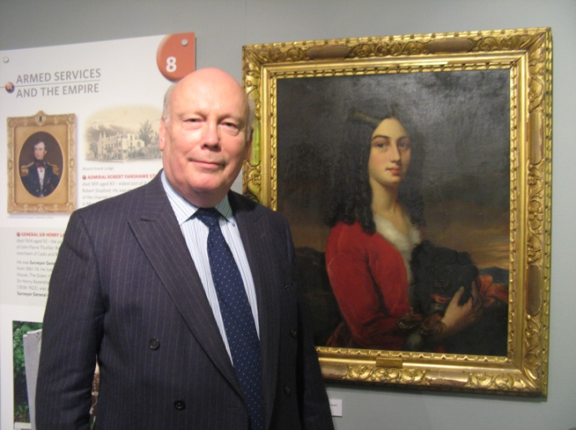**

*(Photo Tony McSweeney)*

**Note to editors**

1. The Museum’s exhibition is “1914 – 1918: Richmond at Home and at War” has just closed. It is followed by “Feeding London: the forgotten market-gardens” which will run from 1 May to 1 September, 2015.

2. The Museum has always had a strong body of Patrons since its inception, including our Royal Patron, H.R.H. Princess Alexandra. Sadly three of our founder Patrons died last year – Lord Attenborough, John Cloake (diplomat, local historian and founder chairman) and Bill Reid (former Curator of the National Army Museum).