

**21st August 2015 Press Release**

**Museum of Richmond New Exhibition:**

**75 years after The Battle of Britain – Richmond Remembers World War Two**

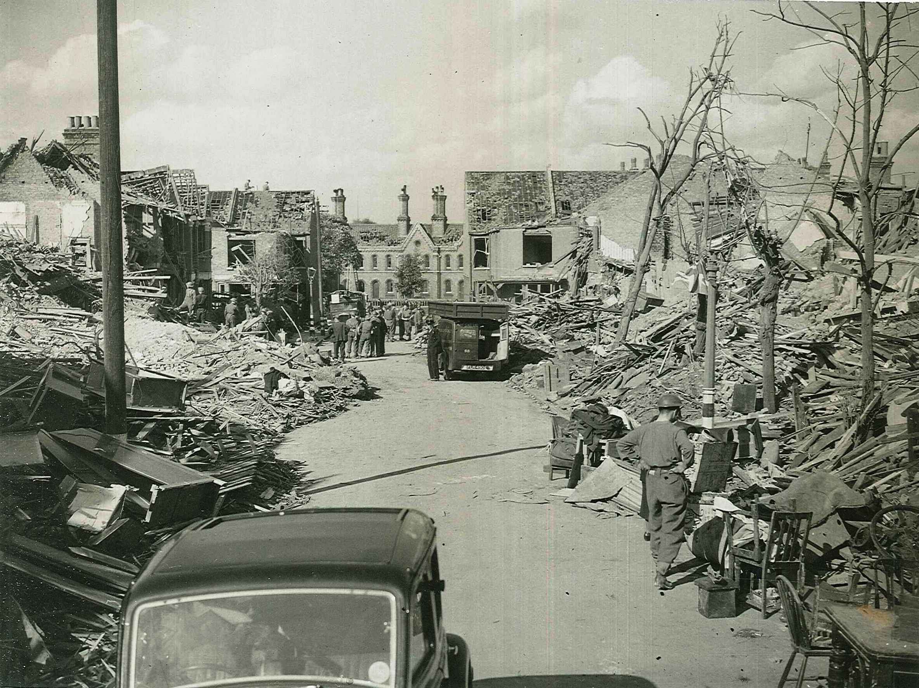

**15th September 2015 to March 2016**

**To mark the 75th Anniversary of the Battle of Britain, the Museum of Richmond has collaborated with The Richmond Local History Society to create an exhibition recounting Richmond’s experience of the Second World War.**

1940 Peldon Avenue ©Richmond Local Studies

Through displays of private artefacts, photographs, letters and reminiscences from local people, this exhibition relates the fascinating and moving stories of Richmond’s Second World War experience.

With insight from local historian; Simon Fowler, the exhibition focuses on experiences of those on the Home Front during the conflict. It tells us about the effect of the Blitz, rationing, evacuation, Civil Defence efforts and many other aspects of everyday life.

Richmond saw its fair share of bomb damage in WWII the worst in 1940 where raids destroyed most of Peldon Avenue, off Sheen Road. The same year the Old Town Hall and the British Poppy Factory Shelter both received direct hits. Bombings continued in April 1941 and then not again until 1944 when Richmond was visited by a new threat from the air – the V2 flying bomb.

During the early stages of the War Richmond residents recall digging trenches in their gardens to build corrugated iron shelters to protect them from the Blitz. Although some would simply shelter in their basements or under the dining room table.

Richmond has always been a popular destination for day trippers and this was still the case during the War. People came to get away from it all, increasing the Councils income from deckchairs, but causing no end of worry for the Air Raid Precautions Wardens, who knew there would not be enough room for everyone in the air raid shelters.

This engaging and informative exhibition provides a detailed look at how everyday life was changed by the war and how local people got involved in the war effort. The Museum thanks London Borough of Richmond upon Thames for helping to fund this exhibition through a Civic Pride award

The exhibition opens at the Museum of Richmond on 15th September 2015 and will run until March 2016. The exhibition is free and will be accompanied by a range of events and educational opportunities. Opening times for the museum are Tue-Sat 10am to 5pm. Enquiries 0208 332 1141 or museumofrichmond@btconnect.com

**Notes to editors**

The Museum of Richmond is an independent museum, registered as a private company limited by Guarantee and a registered charity. While it receives financial support from the London Borough of Richmond upon Thames through Commissioning, this does not cover the running costs, so the Museum depends on pro-actively fund-raising in order to be able to open, look after its collections and to offer its regular programme of exhibitions, education sessions for schools and adult and family events.

THE RICHMOND LOCAL HISTORY SOCIETY holds talks on the history of Richmond, Kew, Petersham and Ham, publishes books and an annual journal, and organises visits to places of historic interest. **The Richmond Local History Society is a registered charity.**

**For further information, images and interviews please contact:**

Natascha Wintersinger (Curator) at The Museum of Richmond on 02083321141 or [mor.curator@btconnect.com](mailto:mor.curator@btconnect.com)

Morag Calderbank (Education and Audience Development Officer) at The Museum of Richmond on 02083321141 or mor.education@btconnect.com