**MR_clock_logo_black_background**

**The Museum of Richmond presents ‘Recruitment and Conscientious Objection’**

**A talk by WWI Historian Dr Chris Kempshall**

As part of a series of events to coincide with our WWI exhibition, Dr Kempshall will be discussing recruitment and conscientious objection with an audience at the Museum of Richmond on

April 1st 2015 at 2pm.

* **Recruitment**

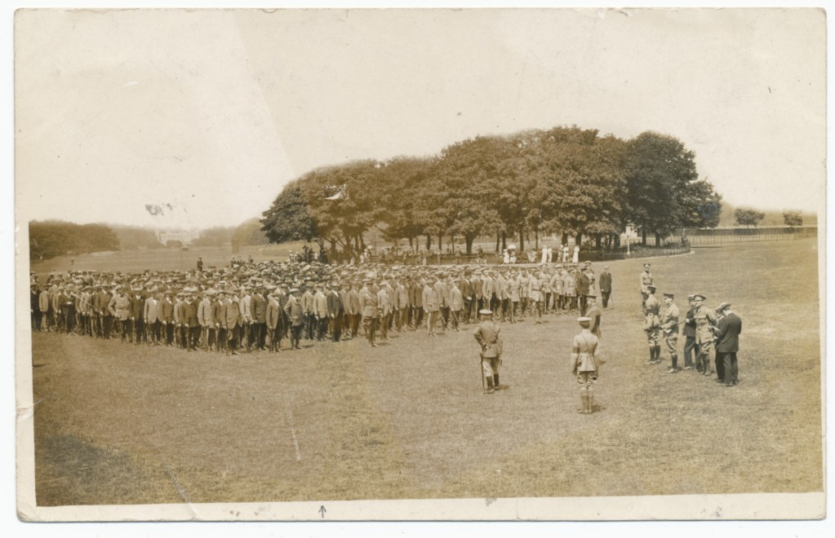 Recruitment in 1914 was not instantaneous. The war began on 4 August but it was not until after the first major battle; Battle of Mons on 23rd August that recruitment soared.

* **Conscientious Objection**

*‘Britain was the only major protagonist which recognised conscientious objection as a valid reason to refuse conscription.’*

The number of British men who objected to conscription on grounds of their conscience is much smaller than you might think.

*Recruitment in Richmond Park*

16,500 men refused conscription through conscientious objection, a figure that is 0.33% of the total number of men who served in the army.

Of this number 1,300 men were imprisoned as a result of their military tribunal. Included in this was pacifist Bertrand Russell who lived at Pembrooke Lodge in Richmond.

‘*We really appreciate having an expert insight into such an interesting topic’* Morag Calderbank Education Officer, Museum of Richmond.

**Dr Chris Kempshall**

Dr Chris Kempshall is an Associate Lecturer at the University of Kent, an Associate Tutor at the University of Sussex, and the Project Officer for First World War Commemorations at East Sussex County Council. He is currently a member of the Academic Advisory Board to the Imperial War Museum, and has recently appeared as an expert on ‘Who Do You Think You Are?’ for BBC1.

**Tickets** – are a recommended £2 donation, please contact the Museum on 0208 332 1141 or email [museumofrichmond@btconnect.com](mailto:museumofrichmond@btconnect.com) to book your place.

**Exhibition – ‘**1914-1918 Richmond at Home and at War, Local stories and their International Links’ runs at the Museum of Richmond until April 22nd 2015. The Museum of Richmond is open Tue-Fri 11am-5pm and Sat 11-4pm.

**Notes to editor**

The Museum of Richmond is an independent museum, registered as a private company limited by Guarantee and a registered charity. While it receives financial support from the London Borough of Richmond upon Thames through Commissioning, this does not cover the running costs, so the Museum depends on pro-actively fund-raising in order to be able to open, look after its collections and to offer its regular programme of exhibitions, education sessions for schools and adult and family events.

The WWIexhibition has been made possible due to an award from the Heritage Lottery Fund.

**About the Heritage Lottery Fund**

Using money raised through the National Lottery, the Heritage Lottery fund (HLF) aims to make a lasting difference for heritage, people and communities across the UK and help build a resilient heritage economy. From museum, parks and historic places to archaeology, natural environment and cultural traditions, we invest in every part of our diverse heritage. HLF has supported over 300,000 projects with more than £5bn across the UK. [www.hlf.org.uk](http://www.hlf.org.uk)

**For further information, images and interviews please contact:**

Morag Calderbank (Education and Audience Development Officer) at The Museum of Richmond on 02083321141 or [mor.education@btconnect.com](../../../../../../AppData/Local/Microsoft/Windows/Temporary%20Internet%20Files/Content.Outlook/6KAVDZBI/mor.education@btconnect.com)