
MUSEUM of

RICHMOND

The Museum of Richmond is taking part in Culture24’s “Museums at Night”

The Keepers of Time: The clock is chiming for our event on Thursday 15th May.
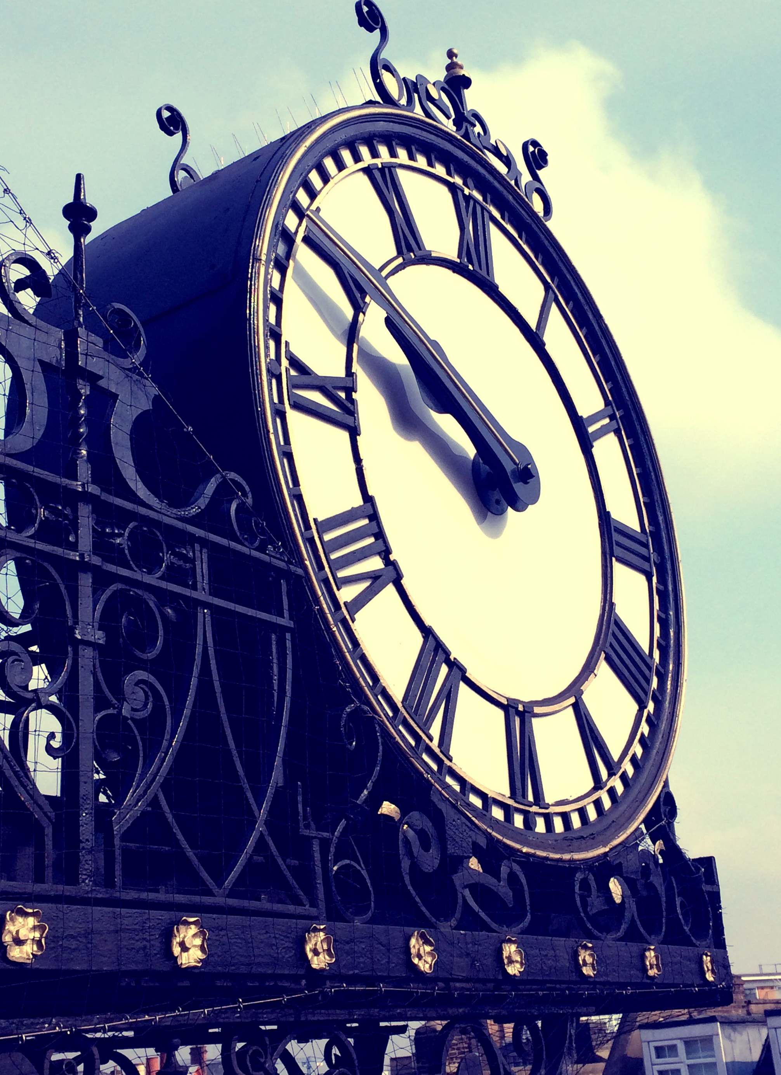
For the very first time, the Museum of Richmond is delighted to be taking part in “Museums at Night”, Culture24's annual UK-wide festival which seeks to encourage visitors into museums by throwing their doors open after hours and putting on a special evening event.

Keep time with The Museum of Richmond and drop in to our free, early evening event where we will be exploring the concept of the museum as a keeper of time. From 5-8pm, we’ll be offering a chance to look behind-the-scenes at the mechanical workings of the Old Town Hall clock, a film screening of Charlie Chaplin’s Modern Times with fun family craft activities, freebies, refreshments and more! We will also be introducing our new logo which is based on the iconic Old Town Hall clock silhouette itself.

Notes to editors
The Museum of Richmond is an independent museum, registered as a private company limited by Guarantee and a registered charity. While it receives financial support from the London Borough of Richmond upon Thames through Commissioning, this does not cover the running costs, so the Museum depends on pro-actively fund-raising in order to be able to open, look after its collections and to offer its regular programme of exhibitions, education sessions for schools and adult and family events.

For further information, images and interviews please contact:
Natascha Wintersinger (Curator) at The Museum of Richmond on 02083321141 or mor.curator@btconnect.com

Jenny Phelan (Education and Audience Development Officer) at The Museum of Richmond on 02083321141 or mor.education@btconnect.com

