
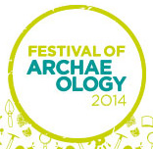
MUSEUM of
RICHMOND

The Museum of Richmond is celebrating the Festival of British Archaeology during July 2014

The Museum of Richmond is delighted to be taking part in the Festival of British Archaeology 2014. Co-ordinated by the Council for British Archaeology, the Festival offers over 1,000 events nationwide, organised by museums, heritage organisations, national and country parks, universities, local societies, and community archaeologists. If you have always wanted to learn more about archaeology, handle real finds, or ask the experts, just us in July at the Museum of Richmond.

Saturday 19th July 11 a.m. - 3 p.m.
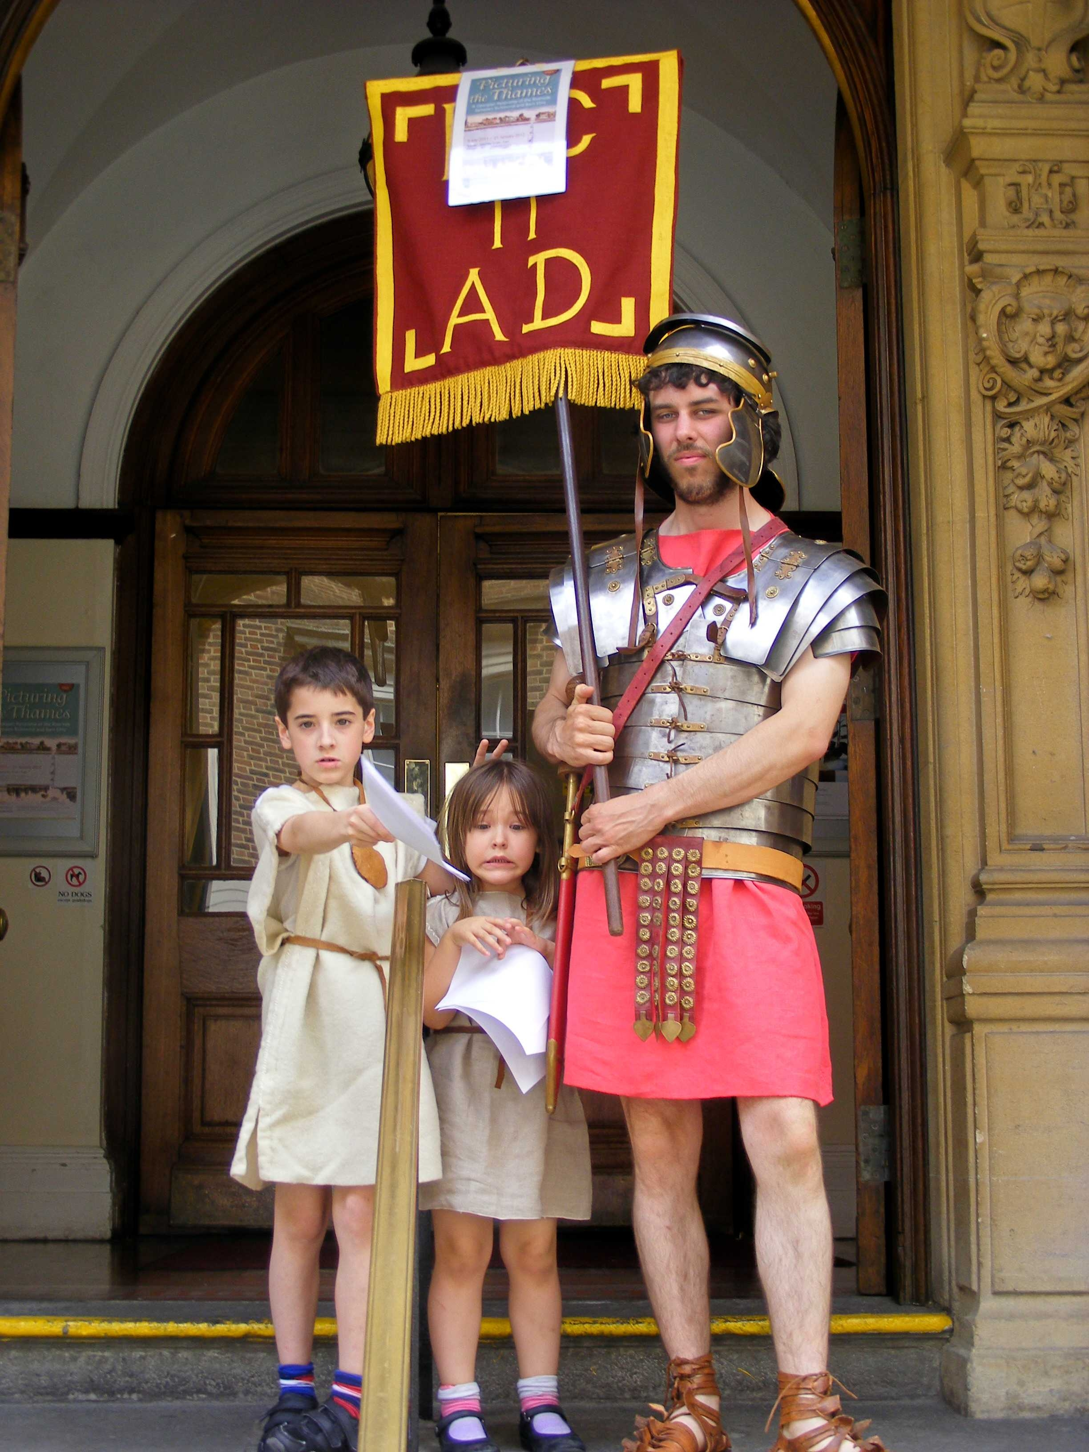
Roman Discovery Day for the Festival of Archaeology
Explore Roman archaeology with Dr Pamela Greenwood during this fascinating and free drop in day. Fun for all ages with Roman artefacts, replica costumes and games.
Free, no booking required.

Wednesday 23rd July 6 p.m. - 8 p.m.
Movies at the Museum: Time Team: A Richmond Palace Special.
Delve into the archaeological foundations of Richmond Palace for the Festival of Archaeology.
£3 donation welcomed, booking required.
Roman Discovery Day 2011 ©Museum of Richmond
Notes to editors
The Museum of Richmond is an independent museum, registered as a private company limited by Guarantee and a registered charity. While it receives financial support from the London Borough of Richmond upon Thames through Commissioning, this does not cover the running costs, so the Museum depends on pro-actively fund-raising in order to be able to open, look after its collections and to offer its regular programme of exhibitions, education sessions for schools and adult and family events.

For further information, images and interviews please contact:
Natascha Wintersinger (Curator) at The Museum of Richmond on 02083321141 or mor.curator@btconnect.com

Jenny Phelan (Education and Audience Development Officer) at The Museum of Richmond on 02083321141 or mor.education@btconnect.com

