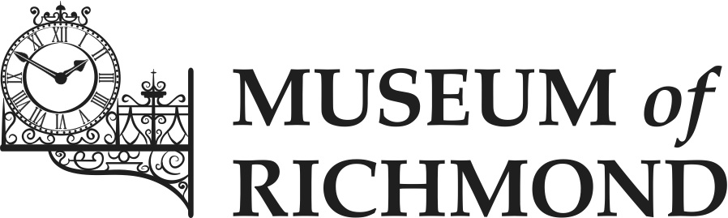

Documentation Procedural Manual

Date created: May 2016
Normal Renewal Date: June 2019
Author: James Scott (Curator)

Contents

Introduction 1
Procedures 2
1. Object Entry 2
2. Acquisition 3
A) Accessions register 4
B) Acquisition – security copy of the accession register 4
C) Acquisition – marking and labelling of objects 4
3. Location and movement control 5
4. Cataloguing 6
5. Object exit 6
6. Loans in 7
7. Loans out 8
8. Retrospective documentation 9
Appendix A: A note on the Adoption of a new Collections Management System 10

Introduction
A documentation procedural manual contains a series of clear documentation instructions intended to standardise the recording of information about the collection of a Museum. The manual provides a central repository of information on documentation. It makes information on documentation practice available to all staff and ensures consistency and continuity of practice in documentation and the adherence to SPECTRUM standards.
The SPECTRUM Standard is an internationally recognised standard of museum collections management, published by the Collections Trust. SPECTRUM describes the activities involved in managing a collection and its associated information. It has guidance on 21 procedures of collections management; from object entry to deaccessioning. This includes 8 primary procedures that are linked to UK Accreditation.
Prior to the creation of this manual, the documentation procedures featured only as part of a review of current procedures in the Documentation Plan. This manual has been created to detail the procedures that the Museum will carry out from the approval of this document, with an emphasis on the SPECTRUM standard.
There may be a scenario in the second half of 2016, in which the Museum will purchase a new collections management system (CMS). This would mean that the Museum should be better placed to adopt documentation procedures to SPECTRUM standard. For more information on the implications of this, see Appendix A. Within this document are procedures that can be carried out using the Museum’s existing database and documentation.

Procedures

Object Entry

SPECTRUM Standard:
- Establish the terms and conditions under which objects are being received for deposit;
- Uniquely identify the newly received object or associated group of objects;
- Ensure the organisation is able to account for all objects left in its care;
- Provide a receipt for the owner or depositor;
- Help establish the extent of the organisation’s liability;
- Indicate the reason for the receipt of the object;
- Determine a finite end to, or programme for review of, the deposit;
- Enable the object to be returned to the owner or depositor as required;
- Allow for objects and associated records to be checked on entry to ensure that they correspond to any accompanying inventory and/or transfer of title documentation supplied;
- Establish who has legal title to the object in case of subsequent acquisition;
- Capture key information about the object, to be augmented in the future;
- Inform the decision making-process.

Entry Forms are in use for objects entering the Museum. A copy of a completed entry form must be given to the depositor. A temporary “E” entry number is assigned to each donation, before the donation is either returned or accessioned. Individual objects are only given an accession number if and when they are accessioned into the permanent collection.
Entry Forms can be found here:
P:\1.3 Collections Management\Documentation and Forms

Acquisition

SPECTRUM Standard:
- Ensure that written evidence is obtained of the original title to an object and the transfer of the title to the acquiring organisation;
- Enable the reconciling of acquisition records with objects as part of retrospective documentation, audit and inventory activity;
- Ensure that a unique number is assigned to, and physically associated with, all objects;
- Ensure that accession registers are maintained, describing all acquisitions and listing them by number;
- Ensure that information about the acquisition process is retained;
- Ensure that donors are made aware of the terms on which their gift or bequest is accepted by the organisation;
- Ensure that collecting complies with the organisation’s collecting policy, and does not contravene any local, national or international law, treaty or recognised code of practice;
- Ensure a copy of the information in the accession register is made and kept up to date.

Accessions register

The acquisition/accession system was changed in May 2008 with the introduction of a bound, archival quality accessions register. This is located within the Museum’s store. Entry Forms have also been introduced. When a decision has been made to accept an object described on the Entry Form into the permanent collection, it will be assigned an individual accession number and the details entered by hand into the accessions register.
The accessions register should only be used to record new additions to the collection (whether these are newly-donated items or items that have previously entered the Museum but have not been accessioned).

Acquisition – security copy of the accession register

Back-up photocopies of the Donation Forms are kept in the history files. The computer catalogue is also backed up and security copies are kept off site. In future, security copies of the new accessions register can be made as required.

Acquisition – marking and labelling of objects

All items in the collection must carry their unique identity number in a way that is as permanent as possible, Objects will be temporarily labelled with the “E” number assigned to them at entry into the Museum and then subsequently marked with the accession number assigned to them when they are recorded in the accessions register. The object’s number will reflect the order of donations within a particular month or year. For example, the first object donated in February 2016 will have the number 2016.2.1. The main concerns that need to be addressed when physically labelling an object are that the label or marking should be:
- Secure – The chances of accidental removal of the label or mark from the object must be extremely low;
- Reversible – It should be possible for a label or mark to be removed intentionally from an object, even after 50-100 years with as little trace as possible;
- Safe for the object – Neither the materials applied to the object nor the method by which they are applied should risk significant damage to the object;
- Discreet but visible – The recommended methods should not spoil the appearance of the object, nor obscure important details. However, the number should be visible enough to reduce the need to handle the object;
- Convenient and safe for staff and volunteers – Materials should be easily available in small quantities at a reasonable price, and should not pose significant risks to health if used in accordance with the guidelines recommended by a local CoSHH (Control of Substances Hazardous to Health) risk assessment.

Location and movement control

SPECTRUM Standard:
- Provide a record of the location where an object is normally displayed or stored;
- Provide a record of the location of an object when it is not at its normal location;
- Enable access to location information by, at the very least, object number and by location name;
- Provide an up-to-date record of the relocation of an object within the physical or administrative boundaries of the organisation;
- Provide an up-to-date record of any movement of an object across the physical or administrative boundaries of the organisation;
- Provide a record of the person responsible for moving an object;
- Provide a record or a statement of the persons responsible for authorising object movement;
- Provide a history of an object’s previous locations, while in the organisation’s care.

Currently, the Museum uses its Lotus Approach database to monitor the location and movement of objects, by changing the information in the ‘Location’ field.

Cataloguing

SPECTRUM Standard:
- Provide a level of description sufficient to identify an object or group of objects and its differences from other, similar objects;
- Provide an historic archive relating to an object or cross-references to sources where information can be found;
- Be held in a system that allows convenient access, e.g. using indexes or free-text retrieval.

The Museum’s database has several fields that can be completed during cataloguing:
- In the Museum’s database, any description of the object in terms of its history or physical characteristics is included within the ‘Item’ field.
- The ‘Short Name’ field is what type of object it is (e.g. shoe, pamphlet, weapon).
- ‘Topic’ can be period or theme (e.g. Law and Order or Second World War.
- ‘Location’.
- ‘Dimensions’ (in mm).
- ‘Update by’ (the cataloguer).
- ‘Last update’ (date the object was catalogued).
At least one photograph should be taken whilst cataloguing an object. This can then be stored in P:\1.3 Collections Management\Object Images. The file name should be the objects number. Multiple images of one object should have a,b,c, etc. at the end, for example 2013.4.3a, 2013.4.3b.

Object exit

SPECTRUM Standard:
- Ensure that legal requirements and the organisation’s policy are fulfilled when objects leave its premises;
- Ensure that the organisation is able to account for the exit of all objects from its premises, including those which have been deposited as offers or for identification or loaned;
- Ensure that location information for accessioned objects leaving the organisation’s premises is maintained;
- Ensure that all objects leave with appropriate authorisation;
- Ensure that a signature of acceptance from the recipient is always obtained when transferring custody of an object between parties. Where the first recipient is a courier it may also be necessary to get a signature from the person or organisation to which it is being delivered.
The Museum has an Exit Form which should be used for objects leaving the Museum that are not for the purpose of a loan. If the object is leaving the Museum due to deaccession or disposal, an Exit Form should be filled out. In these two cases, object exit must be carried out in accordance with the Museum’s Collections Development Policy (2012)’.
The Exit Forms can be found in:
P:\1.3 Collections Management\Documentation and Forms

Loans in

SPECTRUM Standard:
- Establish the purpose of the loan;
- Enable at least the same care of the borrowed object as if it were part of the permanent collections;
- Include written agreements signed by both borrower and lender before the loan commences, as appropriate to the collection;
- Ensure that the terms and conditions of loan are adhered to;
- Ensure that all loans are for fixed periods;
- Ensure a written record of the loan is retained;
- Enable effective control of the loan process;
- Enable the provision of information about the borrower and the loan as requested by the lender;
- Provide insurance or indemnity cover for the loan period;
- Ensure that up-to-date information about the location of borrowed objects is maintained;
- Ensure that up-to-date information about the security of borrowed objects is maintained;
- Ensure that up-to-date information about the physical well-being of borrowed objects is maintained, including the environment and condition of the objects.
When the Museum receives a loan, a Loan In Form is then completed. Each, loan will receive its own loan number, which will be recorded on the form. Two copies are sent to the lender – one for them to sign and keep and the other to sign and return to the Museum. The signed Loan In Forms are kept in a loose leaf binder.
In addition to the Loan In Form files, the Museum has a system of “history” files, which hold further information relating to the loan, such as correspondence. These are kept in suspension files in loan number order.
There is a loans database, which is on the system.
The Loan In Form can be found here:
P:\1.3 Collections Management\Documentation and Forms

Loans out

SPECTRUM Standard:
- Ensure that all loan requests are assessed according to the organisation’s policy;
- Ensure that there are written agreements signed by both borrower and lender before the loan commences;
- Ensure that the loan is for a finite period;
- Ensure that the organisation retains a record of all loans, including details of the borrower, the venues, the loan period and the purpose of the loan;
- Enable effective control of the loan process;
- Ensure that the borrower confirms their intent and ability to provide an acceptable level of care, security and safekeeping for the object and to conform to the conditions of loan specified;
- Ensure that the loaned objects are covered by insurance or indemnity as appropriate for the duration of the loan period.
The Museum has a Loan Out Form which is available on the system at the below location. Under normal circumstances the borrower will retrieve the loan from the Museum; occasionally the Museum will transport the loan. In both cases, at the point at which the object changes hands, the form should be filled out and both parties should sign and take a copy. In the case where objects are leaving the Museum for conservation treatment, a Loan Out Form should be used.
P:\1.3 Collections Management\Documentation and Forms

Retrospective documentation

SPECTRUM Standard:
- Define the purposes of the organisation’s documentation system. The primary purpose should be to establish accountability and access;
- Define the organisation’s understanding of the backlogs it has;
- Work towards reducing its backlog;
- Review progress on reducing the backlog on a regular basis;
- Work towards an overall improvement in the quality of information held about objects and collections;
- Review progress on the overall improvement in the quality of information on a regular basis.
For information regarding the Museum’s retrospective documentation, see Documentation Plan (2016). Work towards reducing any backlogs should follow the same procedures detailed in this document.

Appendix A: A note on the adoption of a new Collections Management System

The adoption of a new CMS has many implications on the documentation procedures of the Museum, these include:
- If the Museum adopts a CMS that has a facility for an entry sub-database this could be used when objects enter the museum before the object is accessioned or returned.
- The Museum’s catalogue could potentially be a web based program, which ideally will be hosted, maintained and backed up by the provider. There is also scope to include a secure digital accessions register within this CMS.
- A problem with the existing database is that it only records the most recent location in which the object has been. If a new CMS is introduced, when an object is moved, the mover should append the new location to the list of existing and previous locations. The same applies to condition checks; an appended list of condition checks is preferable to having one field.
- With regards to cataloguing, a new CMS would mean that more information can be captured:
  - object number
  - historical information
  - object category
  - physical description
  - dimensions
  - inscriptions
  - materials
  - associations
  - maker
  - date made
  - where made
  - related texts
  - location
  - name of cataloguer
  - date catalogued
  - condition

- When entering information into a CMS, some fields (boxes) can be filled in with any information known about the object. However, in the case of certain fields, such as location, only preset key terms may be selected. This is to ensure consistency; avoiding multiple names for the same location for example (an issue the Museum has at the moment).
- New loans could be entered onto a new CMS, either in a section for loans, or the object will be obviously categorised as a loan (depending on which CMS is in use).
- A new CMS would enable the pairing of photographs with records.

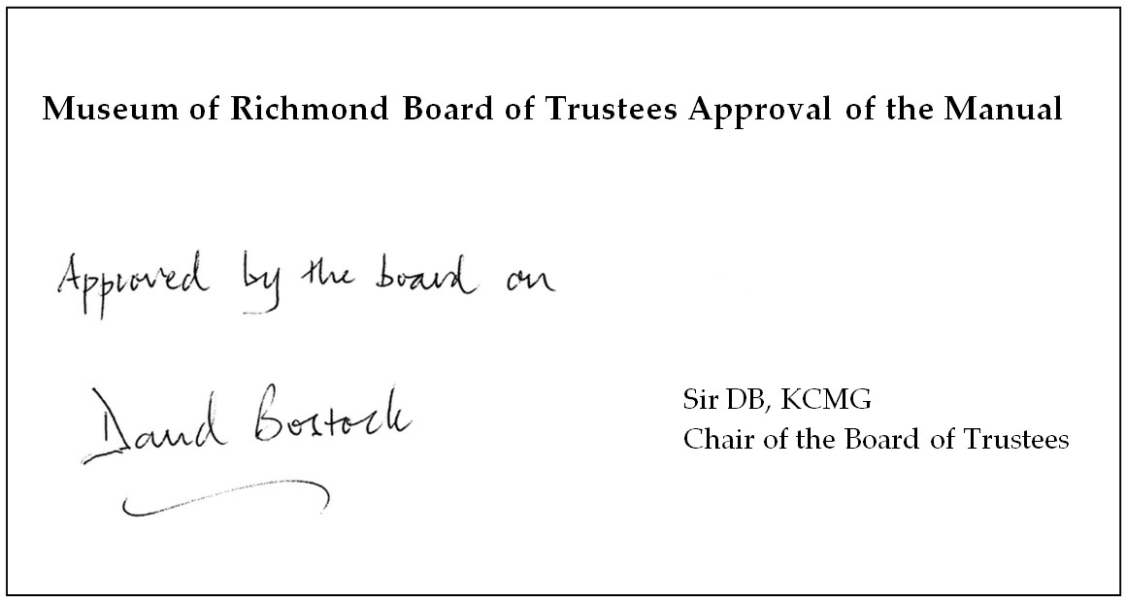
11th May 2016

Due to a potential change of circumstance (the adoption of a new collections management system), this manual may need to be reviewed before December 2016.

