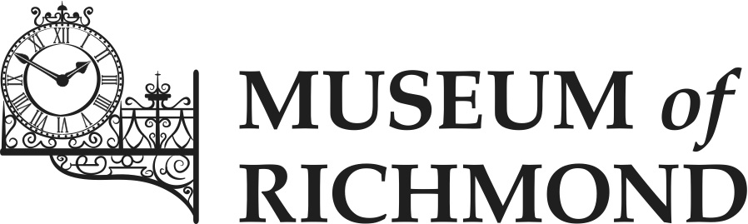

Documentation Plan

Date created: May 2016
Normal review date: June 2019
Author: James Scott (Curator)
Contents

Background & Introduction 2
The Stages of Documentation 3
STAGE 1: Implementation of Policy and Procedures 3
STAGE 2: Identifying and inventory of backlog 4
STAGE 3: Discrepancy Checking 4
STAGE 4: Addressing the Backlog 5
4.1 Acquisition 5
4.2 Location and movement control 6
4.3 Cataloguing 6
4.4 Object exit 6
4.5 Loans in 6
4.6 Loans out 7
Action Plan 8

Introduction

i. The Museum of Richmond was founded in 1986 and opened to the public in 1988. Since then, the collection has grown to almost 5000 objects. These are primarily local and social history artefacts and ephemera. Objects have been acquired both for the Museum’s permanent collection and for use in education sessions and for school loan boxes.

ii. In the 2016 to 2019 period, the Museum faces a potential change to its operating environment. This concerns the Museum’s location. Since its inception the Museum has been sited on the second floor of the Old Town Hall (‘OTH’) in Richmond. The London Borough of Richmond upon Thames (‘LBRuT’), which owns the OTH, is considering revising the use of the building and relocating some of the other services which occupy it; the Museum might be relocated within the OTH as part of this process. It is however not known whether these changes will come to pass; if they do, when they will be made and what will be involved; or when a decision will be taken. As a result, the details of this plan may need to change to reflect changing circumstances.

iii. A further consideration is that the Museum has recently had a changeover of staff, with the employment of a new Curator commencing in February 2016. The present plan represents the new Curator's assessment of documentation priorities, taking account of the uncertainties referred to above and in the light of decisions and discussion with the Board.

iv. The purpose of the Documentation Plan is to evaluate the current state of documentation within the Museum and to detail plans for dealing with the Museum’s documentation backlog and bringing it up to the SPECTRUM Standard. A backlog is an area of a museum’s documentation which is either not up to standard, incomplete or nonexistent.

v. The SPECTRUM Standard is an internationally recognised standard of museum collections management, published by the Collections Trust. SPECTRUM describes the activities involved in managing a collection and its associated information. It has guidance on 21 procedures of collections management; from object entry to deaccessioning. This includes 8 primary procedures that are linked to UK Accreditation. Retrospective Documentation is one of these primary procedures.

vi. This plan will address the four stages of documentation identifying where there are currently shortcomings and will describe changes that will eliminate these. It concludes with a plan that details the timetable for future documentation activities. This includes information regarding what resources are necessary for each activity and who is responsible for carrying them out.

vii. There may be a scenario in the second half of 2016, in which the Museum will purchase a new collections management system (CMS). This would replace the Museum’s current database (a business database, Lotus Approach). In such an event this Documentation Plan would need to be reviewed to respond to the opportunities offered by a new system.

The Stages of Documentation

STAGE 1: Implementation of Policy and Procedures

1.1 The Museum has procedures for accessioning, cataloguing and processing items and these are outlined in the Documentation Procedural Manual (2016). Stage one can therefore be said to be complete.
1.2 This document provides a permanent and easily accessible record of documentation procedures. It ensures their consistent use at the Museum, creating a manual available to all staff, volunteers, Trustees and the general public. The Documentation Plan is available on the public drive (P:) of the office system.
1.3 By adhering to its documentation procedures the Museum will ensure that it conforms to its own Documentation Policy (2012) the Accreditation Standard, and the SPECTRUM Standard.

STAGE 2: Identifying and inventory of backlog

2.1 The Museum began working on Stage 2 in 2006. A series of Assistant Curators, Interns and Volunteers created separate inventories of the collection and backlogs within. This was completed within the period 2014-15.
2.2 Although this inventory can be said to be finished, it is fragmentary in terms of its format (it was created over a long period with numerous individuals adding notes etc.).
2.3 An example of a backlog is the location data on objects. The store was reorganised in 2007 and this may have contributed to this backlog. Location data is not standardised on the database and many of the locations on this system do not match up with locations in the store.
2.4 The Museum’s catalogue does not currently meet the SPECTRUM Standard. The current database lacks fields for certain types of information, for example, condition. In other cases, a field exists, but only a tiny percentage of objects have the field completed, for example, dimensions.
2.5 There are some objects in the store that are unidentified. It will need to be investigated as to whether they have associated documentation.

STAGE 3: Discrepancy Checking

3.1 Stage 3 is a cross reference between the inventory and existing documentation, in an effort to confirm the nature of the collection’s backlogs.
3.2 Work on this began under the previous Curator. Both the Curator and Intern were able to identify several discrepancies between the inventory and existing documentation. However, only part of the collection was checked for discrepancies.
3.3 The Museum plans to carry out an audit of its collection, beginning in late 2016. This will first involve an audit of the stored collection. This will capture data that can be used to check discrepancies within the inventory. It may also highlight other areas of backlog and will eliminate other areas of backlog.

STAGE 4: Addressing the Backlog

Stage four involves undertaking primary SPECTRUM procedures in addressing retrospective backlog items. As discussed above, the Museum will commence an audit which will address several areas of backlog. Below is an analysis of the areas of documentation and details of action that will address backlogs in each area.

4.1 Acquisition

Acquisition – accessions register

The Museum currently uses an accessions register. There are items in the Museum store that have entered the Museum (through donations for example) and have not been formally accessioned. There are also some unidentified items which may need to be accessioned, returned to donors or disposed of (according to ethical guidelines) if they do not conform to the Museum’s acquisition and disposal policy. As the audit will address each and every item in the store, these will be audited and dealt with appropriately.

Acquisition – security copy of the accession register

This was reported as being complete in the Museum’s 2012 Accreditation return. A digital copy of the accessions register had recently been created and is stored on a cloud platform.

Acquisition – marking and labelling of objects

Objects entering the Museum have been marked or labelled with an accession or loan number assigned to them. Objects will be temporarily labelled with the “E” number assigned to them at entry into the Museum and then subsequently marked with the accession number assigned to them when they are recorded in the accessions register. There are items in the collection which do not have a label attached to them. The audit will address this; after an object has been catalogued and photographed, the object will be labelled according to the procedure in the Documentation Procedural Manual (2016).

4.2 Location and movement control

The list of store and gallery locations will be restructured or updated as appropriate. When an item is catalogued during the audit, its location will be updated on the database according to the revised structure.

4.3 Cataloguing

As mentioned in Stage 2, there is a substantial backlog in this area. Eliminating this will be the primary target of the audit. During the audit objects will be catalogued to the standard detailed in the Documentation Procedural Manual (2016).

4.4 Object exit

The Documentation in this area is up to date.

4.5 Loans in

The Documentation in this area is up to date. There may be some items that are on loan that are no longer required and can be returned to their owners. The Loans database will be updated to reflect this.

4.6 Loans out

The Documentation in this area is up to date.

Action Plan
Action | Resources | Personnel | Date of Completion
Investigate the viability of a new CMS and purchase this, if appropriate. | Funding will depend on individual pricing of each CMS, but up front and ongoing costs will have to be taken into account. | Curator, Board | Present options to Board of Trustees on 13/7/2016.
Migrate data from current database and implement new CMS if appropriate. | See above | Curator | By 31/10/16
Create space and organise equipment for audit. | An area large enough to accommodate two volunteers and equipment; Table, Chairs, Tablet or laptop, access to the database, camera,  Lighting, light box, tape measure, acid free labels, writing materials including a graphite pencil; storage material including acid free tissue paper and any additional boxes; acid free labels, latex gloves, cataloguing worksheets. | Curator | By 31/10/16
Update and restructure the locations, both physical and on the database. | Labels and signage. | Curator | By 31/10/16
Recruit & train volunteers to work on audit. | Use of online resources to advertise volunteer positions. | Curator, Volunteer Coordinator | When required and then ongoing.
Catalogue the museum’s stored collection, according to procedure. | See equipment list above. | Volunteers | Begin by 1/11/16  Completion by 11/11/18
Document unidentified objects and objects to be accessioned within the store. | Access to the database, accessions ledger. | Volunteers | 11/11/18
Label objects in the Museum’s store. | Acid free labels, scissors, graphite pencil. | Volunteers | 11/11/18
Return loans items that are no longer needed. | Stationery, packaging materials. | Intern, Curator | 11/11/18

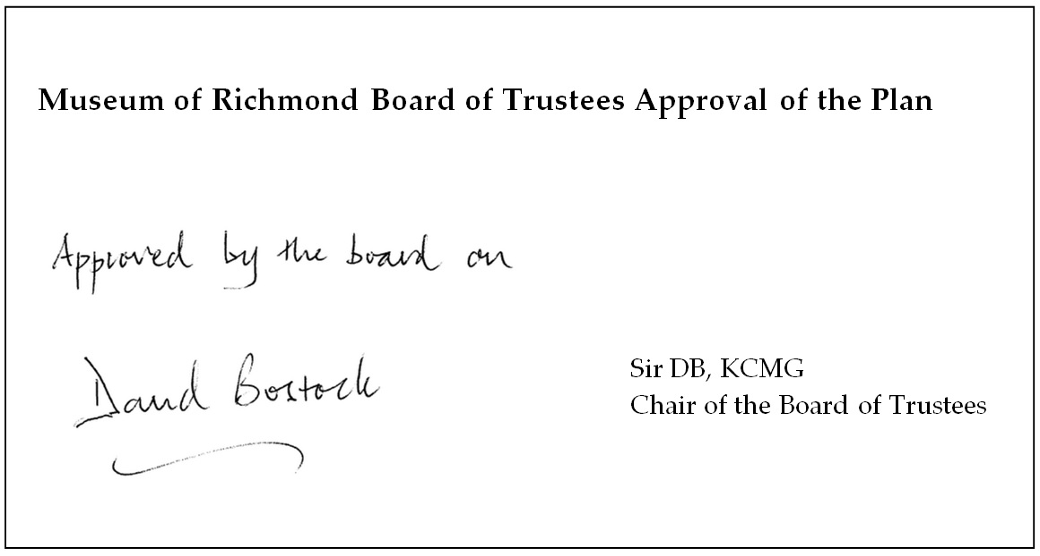
11th May 2016

Due to a potential change of circumstance (the adoption of a new collections management system), this plan may need to be reviewed before December 2016.

