MR_clock_logo_black_background.eps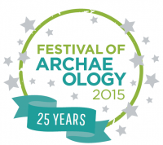

**The Museum of Richmond celebrates local archaeology with two hands-on events in July**

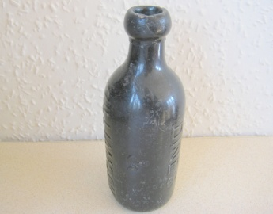The Museum of Richmond is delighted to be taking part in this year’s Festival of Archaeology by hosting two engaging family events on Thursday 23rd July and Saturday 25th July.

Our first event on Thursday July 23rd 12pm -3pm; **Museum of Richmond Archaeology of the Thames**, will involve archaeologists from the Thames Discovery Programme (an organisation which monitors archaeology on the Thames Foreshore) showing off their amazing artefacts. The dates of the artefacts range from half a million years ago to some objects from the present day. The archaeologists will demonstrate how to identify time periods through objects such as clay pipes and they will even bring a human skeleton illustration to help identify bones!

For our second event on Saturday 25th July 12pm -3pm **Museum of Richmond Roman Day,** localhistorian Dr Pamela Greenwood will be inviting visitors to learn about the fascinating life of Romans. There will be Roman artefacts to explore, costumes to try on, activity sheets and even mystery objects to identify.

*Free no booking required*

The Festival of Archaeology - coordinated by the Council for British Archaeology (CBA) - encourages everyone to explore the archaeology of their local area, watch experts at work, and experience archaeology for themselves. Last year over 1,000 events nationwide, organised by museums, heritage organisations, national and country parks, universities, local societies, and community archaeologists. This year the Festival of Archaeology celebrates its 25th year!

If you have always wanted to learn more about archaeology, handle real finds, or ask the experts, visit us in July at the Museum of Richmond.

**Event details**

**Museum of Richmond Roman Day**

**Saturday 25th July, 12pm to 3pm (drop in)**

Museum of Richmond,

Old Town Hall (Second Floor)

Whittaker Avenue,

Surrey, TW9 1TP

*Free Entry, open to all ages*

**Museum of Richmond Archaeology of the Thames**

**Thursday 23rd July, 12pm to 3pm (drop in)**

Museum of Richmond,

Old Town Hall (Second Floor)

Whittaker Avenue,

Surrey, TW9 1TP

*Free Entry, open to all ages*

**Notes to editors  
  
The Council for British Archaeology (CBA)** For almost 70 years the Council for British Archaeology, as an educational charity, has been promoting archaeology for all and is the leading voice for the public interest in archaeology. Active both in Westminster and with grassroots community groups, the CBA works with professionals and the voluntary sector to safeguard the UK's historic environment and make the case to decision makers that archaeology matters.  
  
**The Museum of Richmond** is an independent museum, registered as a private company limited by Guarantee and a registered charity. While it receives financial support from the London Borough of Richmond upon Thames through Commissioning, this does not cover the running costs, so the Museum depends on pro-actively fund-raising in order to be able to open, look after its collections and to offer its regular programme of exhibitions, education sessions for schools and adult and family events.  
  
**For further information, images and interviews please contact:**Natascha Wintersinger (Curator) at The Museum of Richmond on 02083321141 or mor.curator@btconnect.com

Morag Calderbank (Education and Audience Development Officer) at The Museum of Richmond on 02083321141 or [mor.education@btconnect.com](../../../AppData/Local/Microsoft/Windows/Temporary%20Internet%20Files/Content.Outlook/6KAVDZBI/mor.education@btconnect.com)